 |  | Pimpri Chinchwad Education Trust’s  Pimpri Chinchwad College of Engineering
 | FA-1 Activity

Department: Computer Engineering Academic Year: 2025-26 Semester: V

Class: T.Y. B.Tech Div.: D Date: 11/09/2025 Subject: DMW

Name of the Student: Piyush Patil PRN: 123B1B220

Question No.: 14

Problem Statement: OLAP – Hospital Appointments
- Create hierarchy (Year -> Month -> Day) for Appointments
- Roll-up data from Doctor -> Department -> Hospital and show the appointment count

Solution:

Hospital Appointment Monitoring System

1. Dataset Information
The dataset used for this analysis contains 120 hospital appointment records for CityCare Hospital. It includes:
- 10 Doctors assigned across 4 Departments (Cardiology, Neurology, Orthopedics, Pediatrics).
- A single hospital entity (CityCare Hospital).
- Appointment details with Appointment ID and Appointment Date (supporting Year → Month → Day hierarchy).
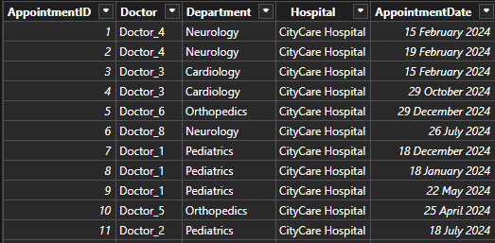
This dataset was created to support OLAP-style analysis of hospital appointments.

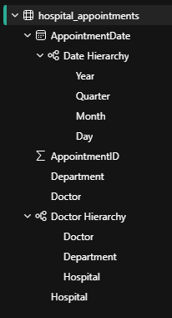

2. Solution for the Problem Statements
a) Hierarchy (Year → Month → Day)
- Implemented a Tree Graph showing the date hierarchy for appointments, allowing drill-down from year → month → day.
- Enables time-based trend analysis of hospital appointments.
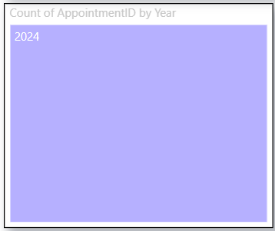
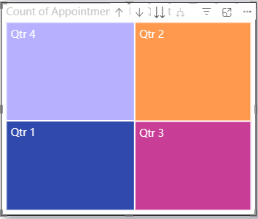

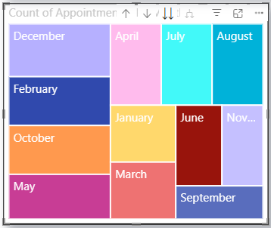
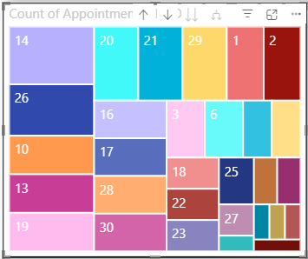

b) Roll-Up (Doctor → Department → Hospital)
- Added a Tree Graph to roll-up appointments from Doctor → Department → Hospital, showing the aggregated count of appointments at each level.
- A Card visualization was used to display the total count of appointments (120).
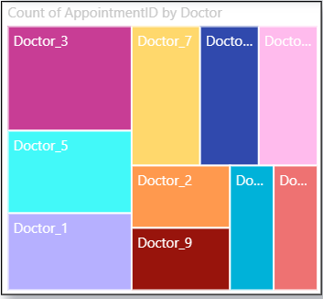
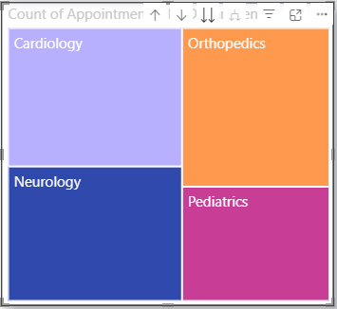
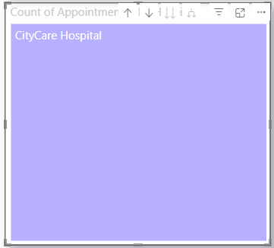

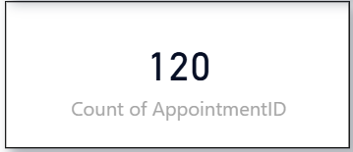

3. Additional Insights & Enhancements
Beyond the given requirements, additional visualizations and features were added for deeper insights:
- Scatter Plot:
  - Plots appointments per doctor.
  - Includes an Average Appointment Count line and a 90th Percentile line to highlight performance benchmarks.
  - Added Zoom Slider for interactive filtering.
- Bar Chart (Stacked by Department & Doctor):
  - Displays count of appointments grouped by department and subdivided by doctors.
  - Appointment counts are shown as values on the bars.
  - Added Zoom Slider for detailed exploration.
- Donut Chart:
  - Visualizes the percentage distribution of appointments across departments.
- Ribbon Chart:
  - Shows the trend of appointments per doctor across quarters.
  - Helps identify doctor-wise appointment dominance over time.
- Treemap:
  - Quick overview of appointments by doctor with proportional sizing.

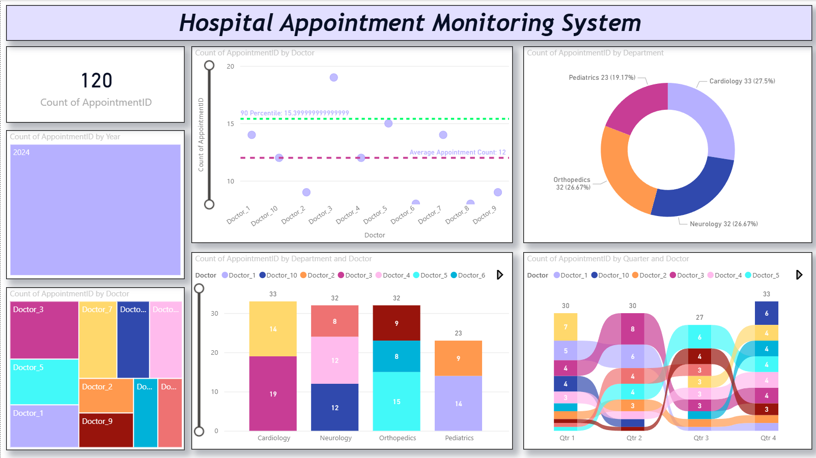

4. Key Takeaways

- Cardiology and Neurology show the highest number of appointments (33 & 32), while Paediatrics is comparatively lower.
- Doctor-wise distribution highlights workload imbalance, with certain doctors handling significantly more patients.
- The scatter plot lines (average & 90th percentile) help in identifying doctors performing above or below benchmarks.
- The dashboards enable multi-level drill-downs, time-series tracking, and departmental comparisons for hospital management.

